**Automatic Number Plate Detection and Recognition (ANPR)**

**Wifreframe Documentation**

**-By Yatrik Shah**

**User Interface of the Project**

User Interface or the Frontend of the project is created with the help of HTML and CSS.

The Flask Framework is used to integrate frontend with the backend.

The Project is deployed on the NeuroLab server(Paas) .

**Home Page**

This is the Homepage of the Project.

Enter Car Image Here

**Prediction Page**

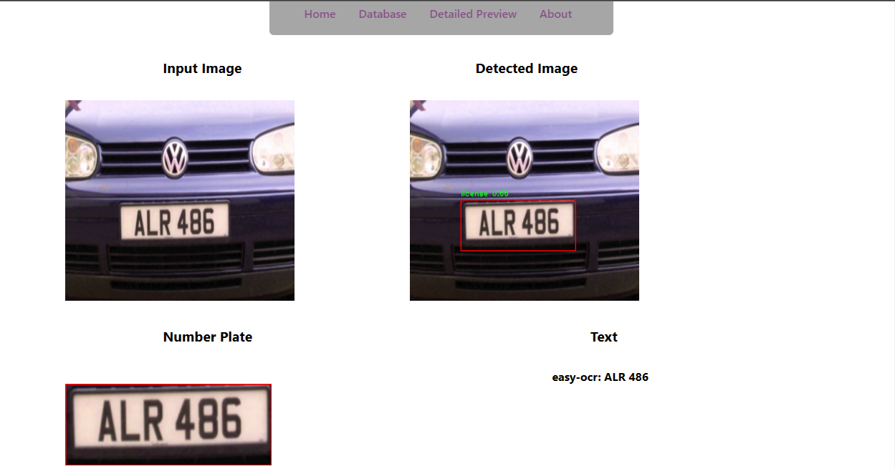

This is the prediction page of the project.

Here Jinja2 template is used, So that At the time of actual prediction instead of “{{result}} “ the actual predicted value will be there.

**Error Page**

This is the error page in case of any kind of error occurred.

This shown page is in case of any invalid input entered by the user.

**Message Page**

This is basically a message page.

This is only used in case of the server failed to Retain the model

[ This kind of situation only occurs when there is some server problem,

Because (1) Heroku server provides less amount of RAM

(2) If the model is not retained within the 30 seconds then Heroku

Server throws “Request Timeout Error”

Database Page:

